Business Requirement Document
Project Name: Enhancements in CEL: GPS Functionality, Find Aadhaar, POR Document Scanning
Project FP Code: FP/PRJ276
Project Owner: Pankaj Kumar Choudhary
BRD Version No: 0.2

Table of Contents
1. Executive Summary 4
2. Acronyms /Abbreviations 4
3. Scope 4
3.1. Included in Scope 4
3.2. Excluded from Scope 5
4. Business Overview 5
4.1. AS IS 5
4.2. TO BE 5
5. Stakeholders 5
6. Requirement Summary 5
7. Requirements Details 5
7.1. GPS 5
7.1.1. Business Process Description 5
7.1.2. Business Rules for Requirements 1 6
7.1.3. Assumption for requirement 1 6
7.2. Find Aadhaar 6
7.2.1. Business Process Description 6
7.2.2. Business Rules for Requirements 2 6
7.2.3. Assumption for requirement 2 7
7.3. Upload PoR (Proof of relationship) 7
7.3.1. Business Process Description 7
7.3.2. Business Rules for Requirements 3 7
7.3.3. Assumption for requirement 3 7
8. Security Requirements 7
8.1. CIA – Rating for the applications 7
9. Fraud Risk Requirements 7
10. Other Information 8
11. Sign off sheet 8
Revision History 9

Executive Summary

Unique Identity Authority of India (UIDAI) issues UID number (Aadhaar) to each and every resident of the country. UIDAI has developed a CEL Client (Android) in which we have a definite process for child enrolment below 5 years where only the demographic details along with photo of the child are captured. As per the child enrolment policy, the enrolment of the child below five years will be carried out without POI/POA documents. The Aadhaar of the operator and parent will be linked to the child so that other demographic details can be populated automatically.
Now there is a need to capture the PoR (proof of relationship) document to verify the relationship of parent with child during child enrolment process. Only the scanned copy of PoR is allowed to upload. There is another need to find the aadhaar in case resident lost his EID/ UID or does not know the EID/ UID. In such case, the resident will get the aadhaar number by providing demographic and biometric details in the presence of concerned operator. Also, it is necessary to locate the position of android client so as to check where the child enrolment process is going on. For this purpose, GPS functionality needs to be added in CEL android client where the user should enable the GPS on mobile before proceeding for child enrolment process.

Acronyms /Abbreviations

Term | Description
UIDAI | Unique Identity Authority of India
POI/POA/POR | Proof of Identity / Proof of Address/ Proof of relationship
CEL | Child Enrolment Client
GPS | Global Positioning System

Scope

Included in Scope
The scope includes the following requirement:
- Capturing GPS coordinates at the time of child enrolment process by referring a 3rd party application and manage it for future references.
- Find aadhaar of parent
- Upload and manage PoR document during enrolment process for future reference (View/ Audit), etc

Excluded from Scope
Section not mentioned in ‘Included in Scope’ is considered Out of Scope.

Business Overview

AS IS

CEL (Child enrolment client), an android tablet based application, allows the child enrolment with few demographic details, biometric authentication and no documents.

TO BE

The “TO-BE” section includes the following requirement:
- Capturing GPS coordinates at the time of child enrolment process by referring a 3rd party application and manage it for future references.
- Find aadhaar of parent
- Upload and manage PoR document during enrolment process for future reference (View/ Audit), etc

Stakeholders
- UIDAI

Requirement Summary

Req. No. | Description | Type | RFP coverage | Cost implication
Req01 | Capture GPS coordinates during child enrollment process. | New | No | FP
Req02 | Find Aadhaar of resident | New | No | FP
Req03 | Upload PoR (Proof of relationship) document feature in child enrollment process | New | No | FP

Requirements Details

GPS

Business Process Description
This feature will allow the user to capture the longitude and latitude of the android device through which child enrolment will be completed. Third party application will be used to implement this feature as a part of child enrolment process. To get the longitude and latitude, GPS should be “ON” on the android device. Once the GPS coordinates start displaying on the device, the user should be able to enroll the child aadhaar and GPS should be enabled throughout the enrolment process. In case GPS is off, the user should not be allowed to perform any enrolment activity.

Business Rules for Requirements 1
- GPS shall be enabled for enabling and completing the enrolment process
- GPS shall be updated every day
- The following values shall be captured:
- Longitude
- Latitude
- Altitude
- The coordinate values shall be displayed in read only mode in the client application.

Assumption for requirement 1
N/A

Find Aadhaar

Business Process Description
This feature will allow the user to fetch resident’s Aadhaar based on demographics and biometric data of the resident by referring various UID Systems (It depends on the aadhaar status that which database to be referred). System must return only one unique Aadhaar number. Once the user logged in into the application, he/ should allow the resident to provide his biometric and demographic details. If the entered details are valid, the aadhaar number will get displayed otherwise system will display the messages based on the various scenarios like aadhaar suspended, no record available, etc. This functionality is useful when resident loses the UID/EID or not known.

Business Rules for Requirements 2
- The following fields should be displayed:
- Name (Mandatory)
- Email (Optional)
- Mobile number (Optional)
- C/o (care of) (Optional)
- State(Optional)
- District/ Pincode (Mandatory)
- YOB (year of birth) (Optional)
- Gender (Mandatory)

- Either District or Pincode should be provided.
- Mobile should be 10- digit value
- Pincode should be 6-digit value
- YOB should be 4-digit value
- The entered demographic and biometric details should return only one aadhaar detail.

Assumption for requirement 2
- Resident should have valid UID to get the aadhaar details
- User should have login credentials to access the functionality

Upload PoR (Proof of relationship)

Business Process Description
Currently while performing child enrolment, the demographic detail of the child is captured while biometric authentication of the parents and operator are captured. Now there is a need to enhance the child enrolment process by capturing the PoR (proof of relationship) document and document type while capturing parent’s biometric. There is a predefined list of PoR document name available for selection. Once the user selects the document name from dropdown box and uploads the scanned document, the operator will verify the PoR document at the time of Enrolment review. Once it is verified, the enrolment process can be completed.

Business Rules for Requirements 3
- The scanned document of PoR should be allowed to upload.
- Only jpeg format should be used.
- The document should be verified before completing the enrolment process

Assumption for requirement 3

Scanned copy of PoR will be available at the time of enrolment

Security Requirements

CIA – Rating for the applications

Fraud Risk Requirements
N/A

Other Information
Screens for accessing the application are as follows:

Upload PoR Document
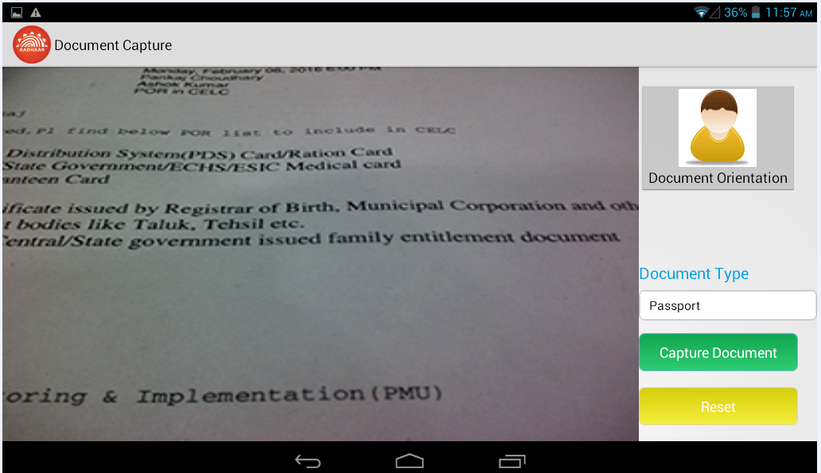

To capture document
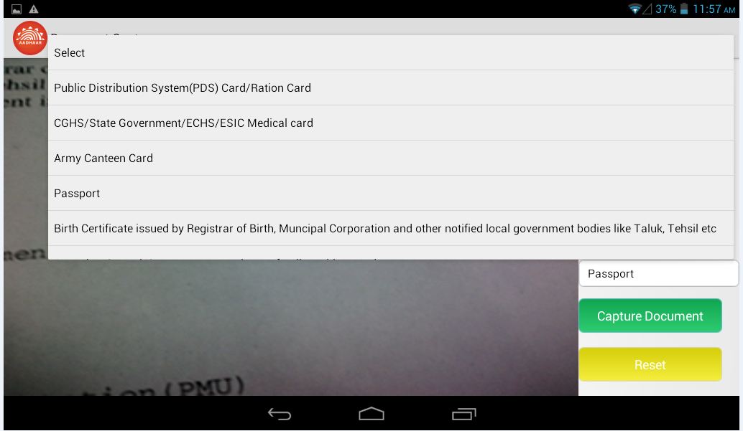

List of documents
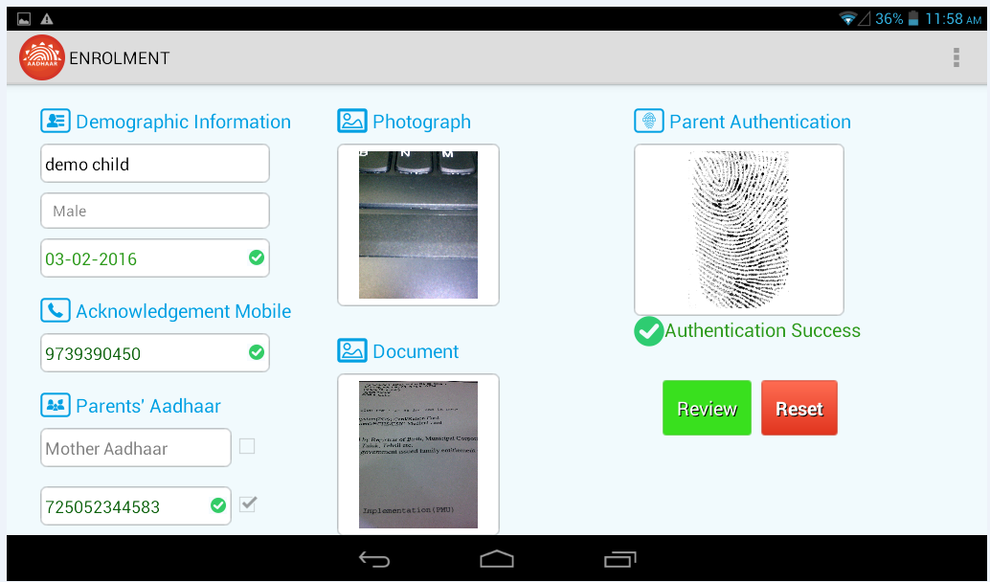

Document is uploaded

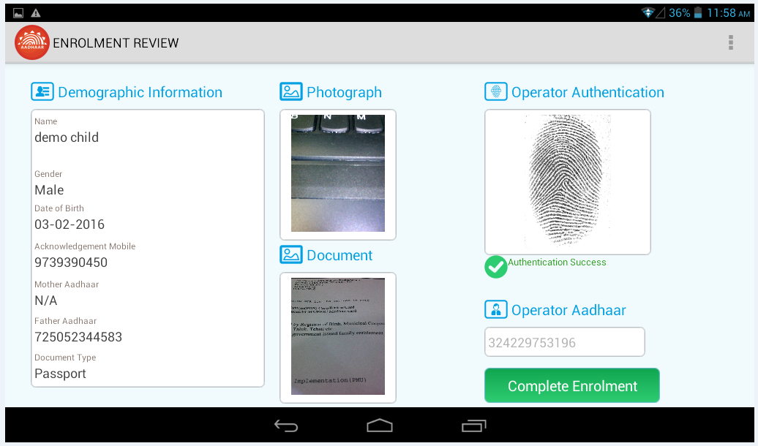

Upload Document is available for review

Find Aadhaar

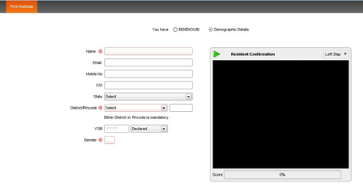

Find aadhaar screen

Sign off sheet

The following parties have been identified as key project stakeholders. Please read the following statement and confirm your acceptance of the business requirements as described in this document.
I have read the Business requirements presented in this document and approve the requirements as being complete for the business needs of the request. My signature below indicates my Commitment and support for the project.

UIDAI / MSP Approvers
Name | Signature | Date

Revision History

Version no. | Date | Author | Description/summary of changes | Reviewed by | Approved by (MSP) | Approved by (UIDAI)
0.1 | 12/02/2016 | Neerav Sachdeva | Initial Draft
0.2 | 17/02/2016 | Neerav Sachdeva | Updated with additional information

